IBM Phase 4

MACHINE LEARNING MODEL DEPLOYMENT USING IBM WATSON STUDIO

Last time , We discussed about development of our project and stated its features, now we will continue our development by deploying the application “laptop price predictor”.

in phase 3, we have created the machine learning model “laptop price predictor” and in phase 3 ,we have tested the dataset of laptop prices, specifications, model, manufacture year, features, etc.

And also we trained the dataset, by which the machine learning model will predict the price of the laptops based on the users or public inputs given.

In this phase , Now we are ready to deploy our machine learning model as a Web service.

To promote the model to deployment you must specify a deployment space. If no space is created choose the New space + option to create one. This action will associate the model with the space.

Navigate to the space using the hamburger menu (☰) on the top right and choose to View all spaces.

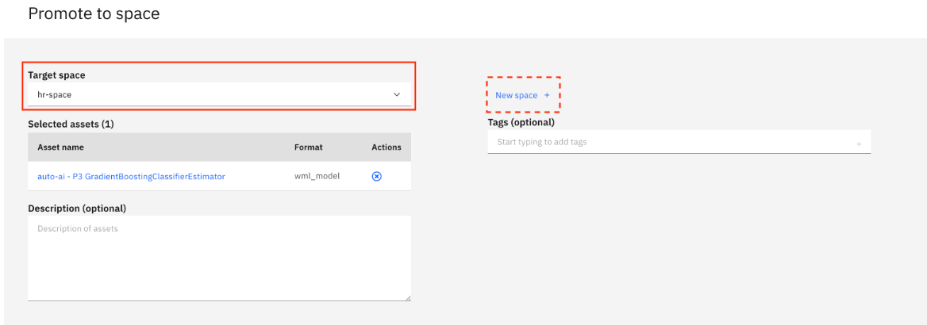

Choose the deploy the model by clicking the rocket ship icon.

Your new deployment will appear. Click on the API reference tab and save the Endpoint. We'll be using this in our application.

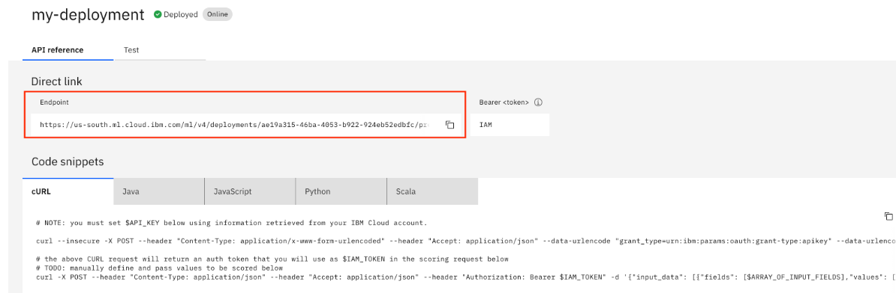

You can deploy this application as a Cloud Foundry application to IBM Cloud by simply clicking the button below. This option will create a deployment pipeline, complete with a hosted Git lab project and devlop toolchain.

You may be prompted for an IBM Cloud API Key during this process. Use the Create (+) button to auto-fill this field and the others. Click on the Deploy button to deploy the application.

Before using the application go to the Runtime section of the application and in the Environment variables tab add in your API_KEY and DEPLOYMENT_URL values.

Once updated your application will restart and you can visit the application by clicking on Visit App URL.

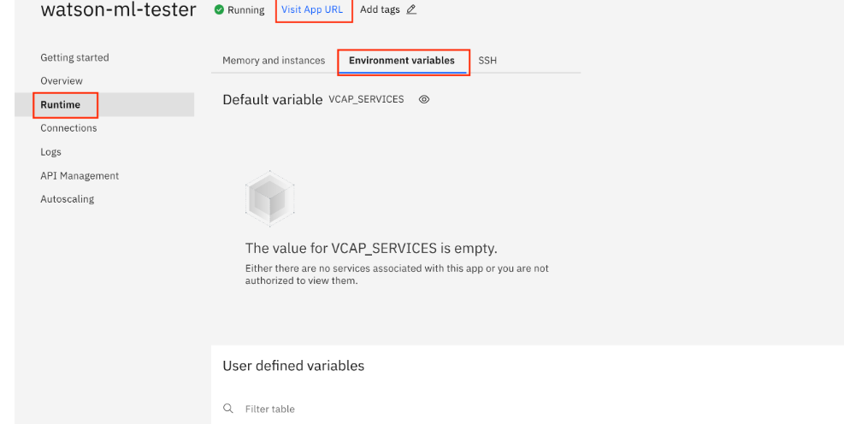

The app is fairly self-explantory, simply fill in the data you want to score and click on the Classify button to test how those figures would score against our model. The model predicts that the price of the laptops based on their specifications.